AI-Based Stock Direction Prediction Model
Abstract
This project presents an end-to-end machine learning workflow for predicting next-day stock price direction using historical market data of Apple Inc. (AAPL). The study involved data collection from Yahoo Finance, feature engineering using technical indicators (Daily Return, Moving Averages, Volatility, RSI, and MACD), and training classification models including Logistic Regression and Random Forest.
The models were evaluated using accuracy score, confusion matrix, and classification metrics. Additional improvements such as indicator expansion and hyperparameter tuning were applied to enhance predictive performance. The results showed accuracy close to the random baseline (~50–52%), highlighting the inherent difficulty of short-term stock direction prediction.
The project demonstrates the complete lifecycle of a financial machine learning system, including preprocessing, modeling, evaluation, and prediction generation, and emphasizes the challenges of forecasting financial markets using technical indicators alone.

AI-Based Stock Direction Prediction Model
Author: Krunal J. Patoliya
Tools Used: Python, Pandas, Scikit-learn, Matplotlib
Dataset: Yahoo Finance (AAPL)
Year: 2026

- Environment Setup & Data Collection
1. Project Overview
This project aims to predict the next-day movement (Up/Down) of a US stock using historical stock market data.
Step 1 focuses on setting up the Python environment and downloading historical stock data.

1.2. Objective
- Install Python and required libraries
- Set up development environment
- Download historical stock data for US stocks (AAPL)
- Understand the structure of the data

1.3. Environment Setup
Software Installed:
- Python (latest version)
- VS Code (recommended code editor)
Libraries Installed:
- pandas – for data manipulation
- numpy – for numerical operations
- matplotlib – for plotting charts
- yfinance – for downloading stock data
Installation command:
Outcome:
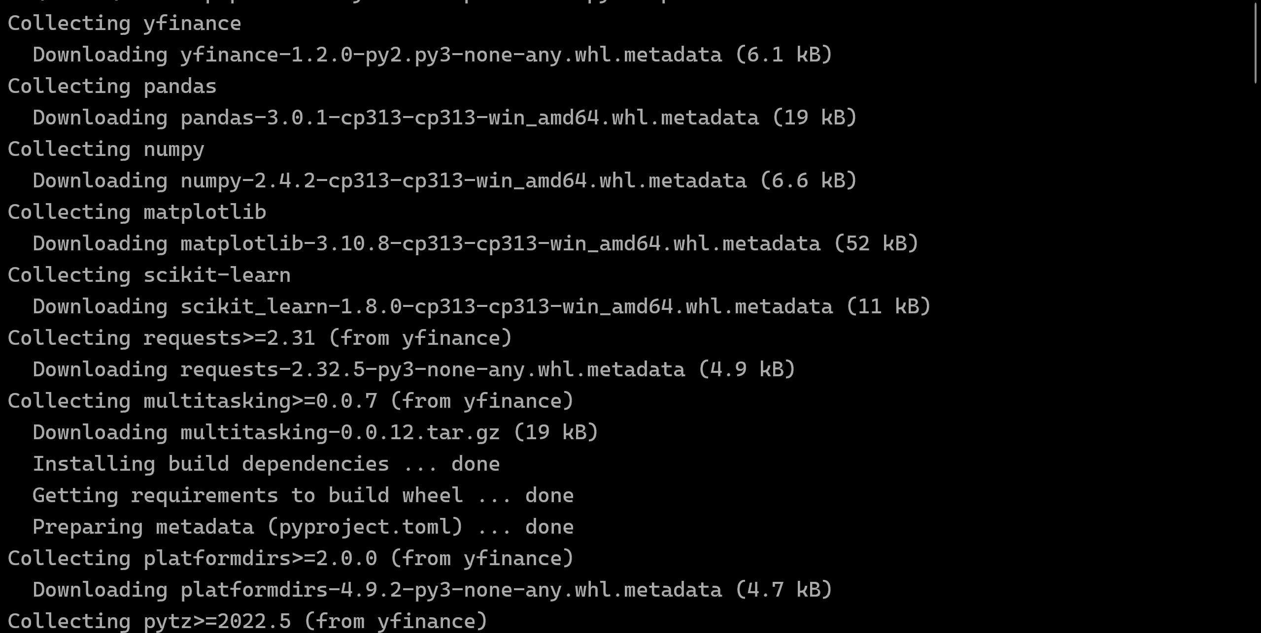
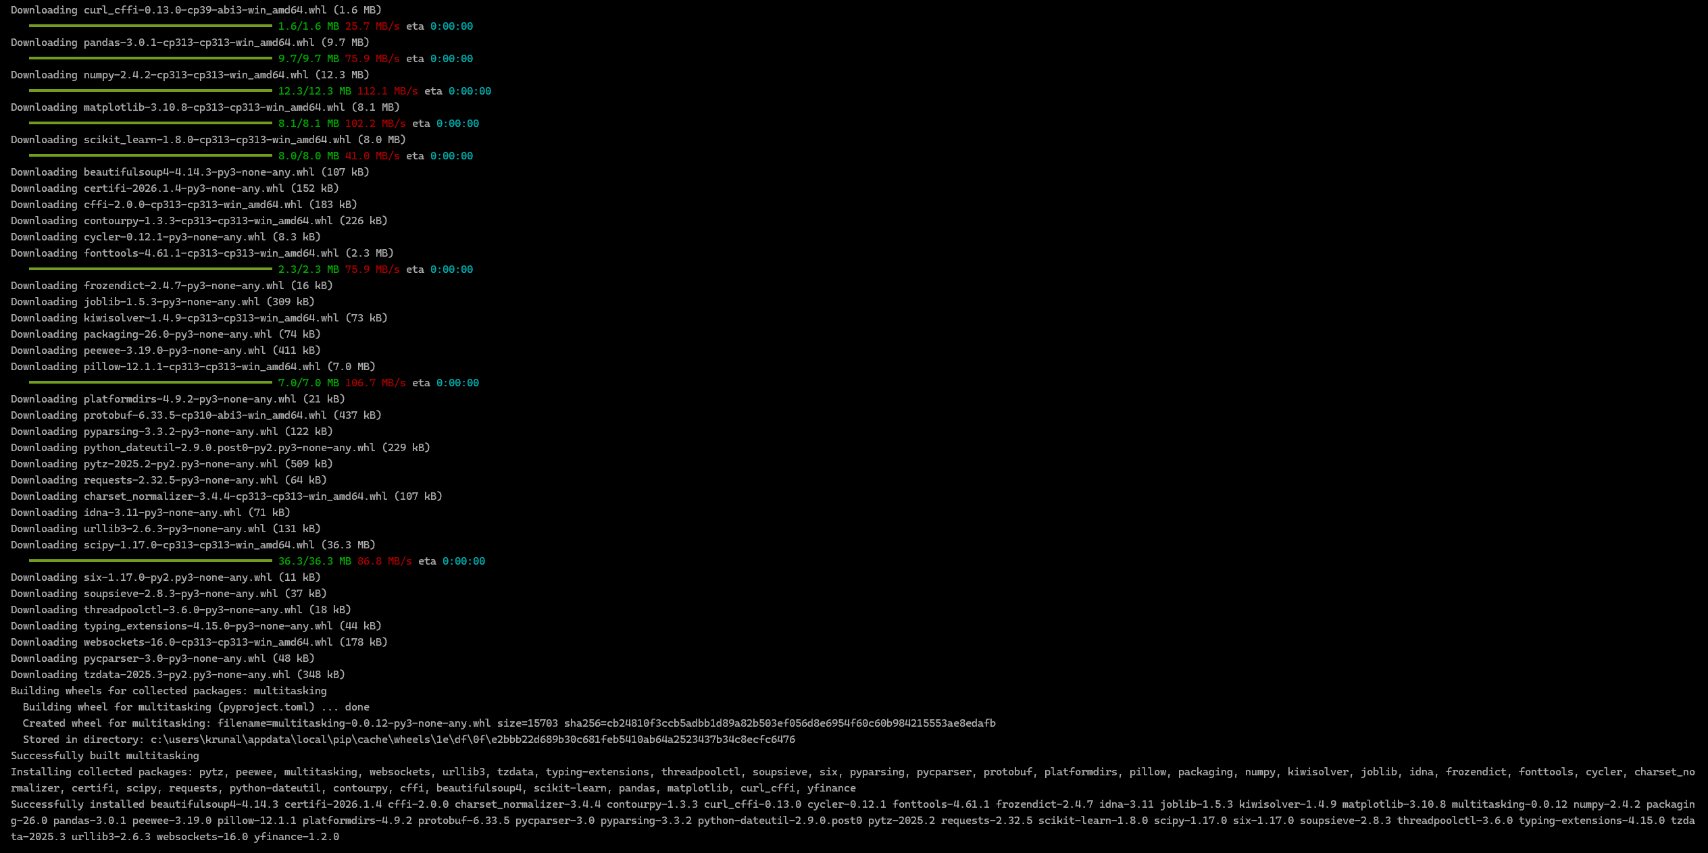
1.4. Data Source
- Historical stock data downloaded using Yahoo Finance.com
- Stock chosen: AAPL (Apple Inc.)
- Time period: 2018 – 2023
- Accessed using Python library yfinance

1.5. Data Description
Downloaded data contains:
Column | Description
Open | Price at market open
High | Highest price of the day
Low | Lowest price of the day
Close | Price at market close
Adjusted Close | Adjusted close (accounts for dividends/splits)
Volume | Number of shares traded

1.6. Steps Completed
- Installed Python and VS Code
- Installed required Python libraries
- Downloaded historical AAPL stock data using yfinance
- Verified data structure and basic information
- Prepared for next step: feature engineering

1.7. Key Learnings
- How to install Python and necessary libraries
- How to download stock data programmatically
- Understanding stock OHLCV data
- Setting up a foundation for ML modeling

Download and Save Stock Data
Objective: Download historical stock data for a US stock (AAPL) and save it as a CSV file.
Steps:
- Open Terminal / Command Prompt
  - Windows: Win + R → cmd → Enter
  - Mac/Linux: Open Terminal
- Create Python Script
  - Navigate to the folder where you want the file (e.g., C:\Users\Krunal\Documents)
  - Create a Python file (stock_data.py) and paste the code to:
    - Download data using yfinance
    - Display the first 5 rows on screen
    - Save the dataset as AAPL_stock_data.csv
- Run the Script
python stock_data.py
- Verify Output
  - Check the terminal to see first 5 rows of data
  - Locate the CSV file (AAPL_stock_data.csv) in your chosen folder
Outcome:
- Stock data is downloaded, displayed, and saved as a CSV ready for analysis.

1.8. Next Step
- Feature engineering: Daily return, moving averages, volatility
- Creation of target variable (Up/Down)
- Prepare dataset for machine learning

2. Feature Engineering & Target Creation

2.1 Project Overview
In Step 2, we transform the historical stock data downloaded in Step 1 into a dataset ready for machine learning. This involves creating new features (daily returns, moving averages, volatility) and the target variable indicating whether the stock price will go up the next day.

2.2 Objective
- Add meaningful features to the dataset for ML modeling
- Create a target variable (Up/Down)
- Ensure all numeric columns are correctly formatted
- Prepare a complete dataset for training models

2.3 Features Created
Feature | Description
Daily Return | Percentage change of the closing price from the previous day
MA5 | 5-day moving average of the closing price
MA10 | 10-day moving average of the closing price
Volatility | Standard deviation of daily returns over 10 days (risk measure)
Target | 1 if next day Close > current Close, else 0

2.4 Steps Completed
- Loaded the entire AAPL_stock_data.csv dataset into Python
- Converted numeric columns to ensure calculations work (Open, High, Low, Close, Volume)
- Created Daily_Return, moving averages (MA5, MA10), and Volatility
- Created the target column (Target)
- Removed rows with missing values caused by rolling calculations
- Saved the new dataset as AAPL_stock_features.csv

2.5 Python Environment / Libraries Used
- Python (latest version)
- Libraries: pandas, matplotlib
Python Script:

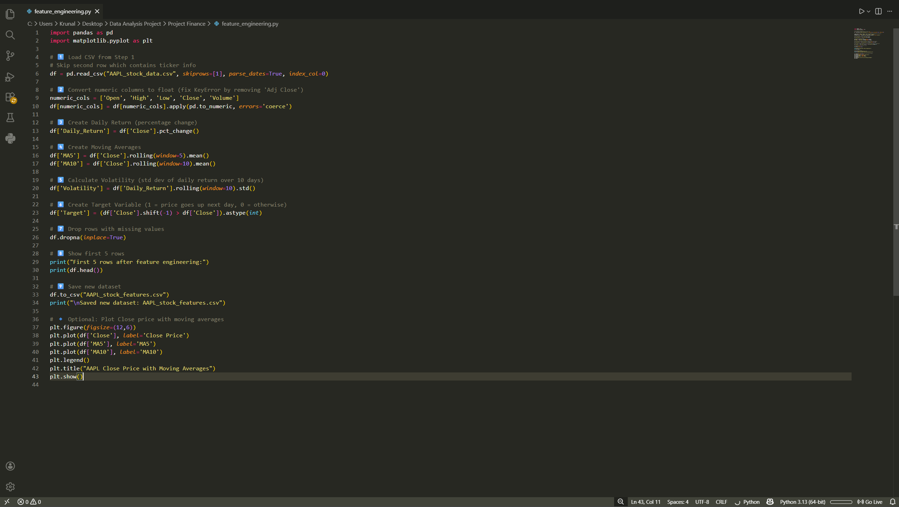
2.6 Outcome
- Full dataset processed for ML with all valid rows
- New features added to help predict stock movement
- Dataset saved as AAPL_stock_features.csv
When an individual run this CSV file, outcome will be shown below:
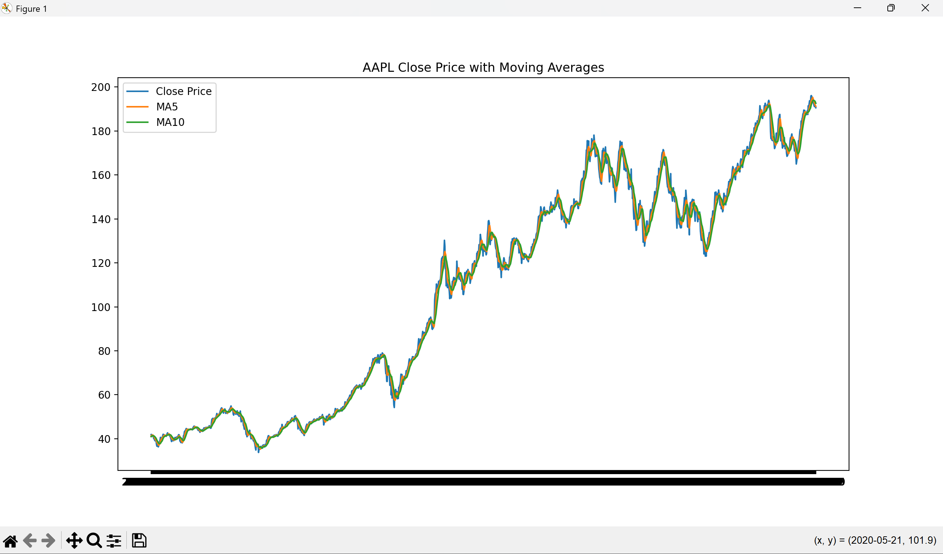

2.7 Key Learnings
- How to create features for stock prediction
- How to calculate moving averages and volatility
- How to create a target column for supervised learning
- Working with numeric and time-series data in Pandas
- Dataset is now ML-ready

2.8 Next Step
- Split the dataset into train and test sets
- Apply machine learning models (Logistic Regression, Random Forest)
- Evaluate model performance using accuracy, confusion matrix, etc.

3. Model Training & Evaluation

3.1 Project Overview
In this step, the machine learning models were trained using the feature-engineered dataset (AAPL_stock_features.csv).
The goal was to predict whether the stock price will move Up (1) or Down (0) the next trading day.

3.2 Objective

• Split the dataset into training and testing sets
• Train machine learning models
• Evaluate model performance
• Analyze feature importance
• Interpret prediction results

3.3 Dataset Preparation
The processed dataset AAPL_stock_features.csv was loaded into Python.
- Features (X):
All columns except the Target column
- Target (y):
Target column
  - 1 = Price goes Up next day
  - 0 = Price goes Down next day

3.4 Train-Test Split
The dataset was divided into:
- 80% Training Data
- 20% Testing Data
Important:
Since this is time-series data, shuffle=False was used to preserve chronological order.

3.5 Machine Learning Models Used
Two models were implemented:
1. Logistic Regression
- A linear classification model
- Suitable for binary classification problems
2. Random Forest Classifier
- An ensemble-based model
- Combines multiple decision trees
- Captures non-linear relationships
Model training and evaluation script.
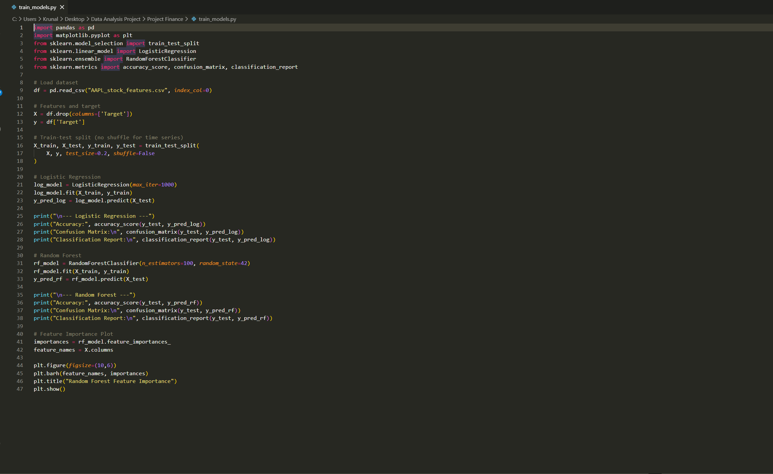

3.6 Evaluation Metrics
Accuracy alone may not fully represent model performance in imbalanced classification problems; therefore precision, recall, and F1-score were also analyzed.
The following evaluation metrics were used:
• Accuracy Score
• Confusion Matrix
• Precision
• Recall
• F1-Score
These metrics help measure how well the model predicts stock direction.

3.7 Results
Logistic Regression Results
- Accuracy: 52.3%
The model slightly outperformed random guessing (50%).
It performed better at predicting upward movements than downward movements.
Confusion Matrix Analysis:
- Correct Down predictions: 52
- Correct Up predictions: 105
- Some misclassification present in both classes

Random Forest Results
- Accuracy: 50%
The model performed close to random baseline.
It showed bias toward predicting downward movement.
Confusion Matrix Analysis:
- Stronger performance for Down class
- Weaker prediction capability for Up class
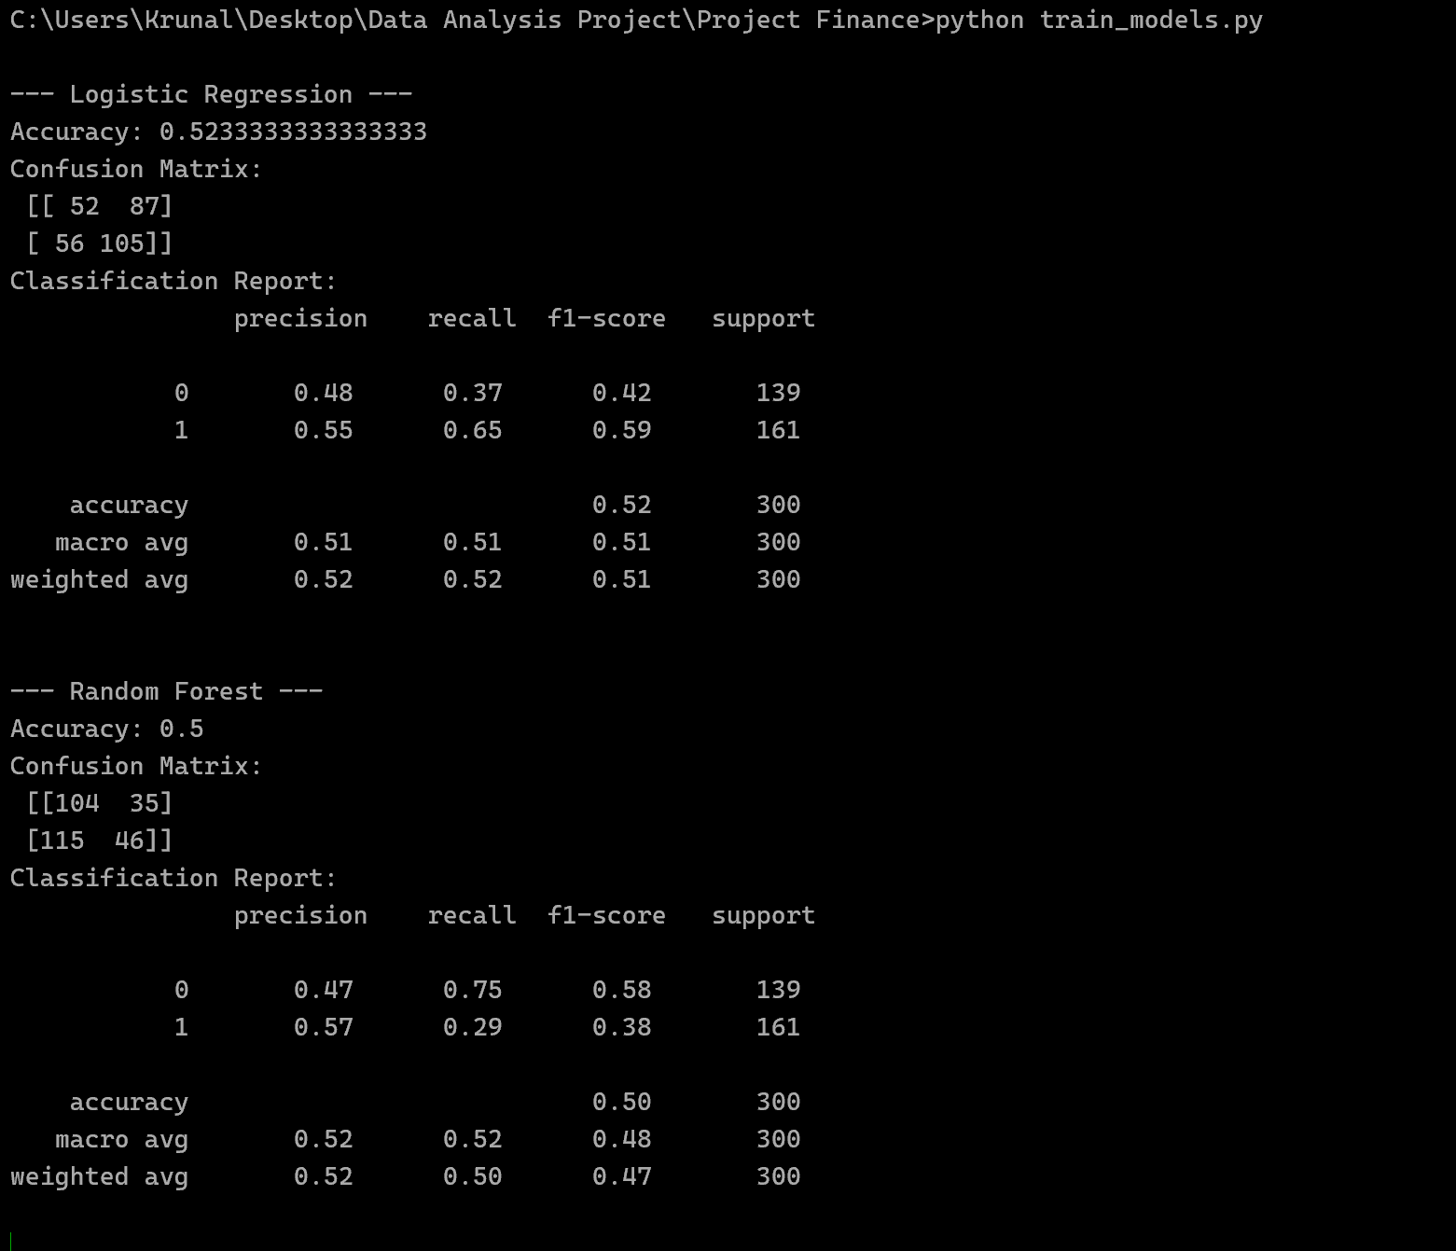

3.8 Feature Importance Analysis
Feature importance from the Random Forest model showed:
• Daily_Return was the most important feature
• Volume and Volatility were significant contributors
• Raw price features (Open, High, Low, Close) had lower importance
This indicates that momentum and volatility play a larger role in short-term stock movement prediction.

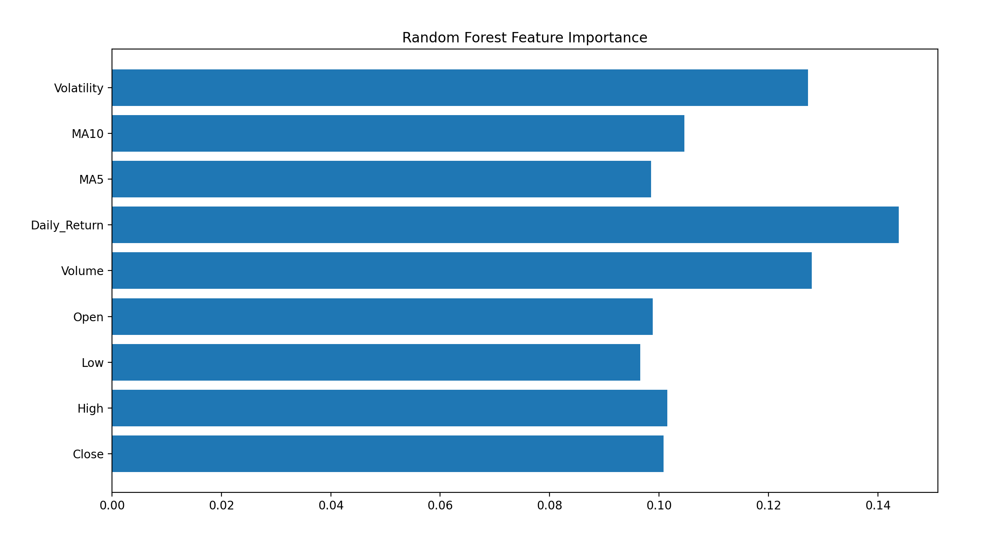The chart shows that Daily_Return is the most influential feature, followed by Volume and Volatility. Moving averages (MA5 and MA10) also contribute significantly, while raw price features (Open, High, Low, Close) have comparatively lower importance.

3.9 Interpretation of Results
Stock direction prediction is inherently difficult due to:
• Market noise
• High volatility
• Efficient market behavior
The models achieved performance close to random baseline, which is common in short-term stock prediction tasks using basic technical indicators.

3.10 Conclusion
• Machine learning models were successfully trained
• Model evaluation metrics were calculated
• Feature importance was analyzed
• The ML pipeline is fully functional
The project successfully demonstrates an end-to-end machine learning workflow for stock direction prediction.

4. Model Improvement

4.1 Project Overview
The model was improved by adding additional technical indicators to the feature set and tuning the machine learning model. The goal was to test whether advanced indicators and better model settings could improve next-day stock direction prediction performance.

4.2 Objective
• Add advanced technical indicators to the dataset (RSI and MACD)
• Rebuild the feature dataset with the new indicators
• Retrain Logistic Regression and Random Forest models
• Tune Random Forest hyperparameters to attempt performance improvement
• Compare updated results with the Day 3 baseline results

4.3 Improvements Implemented
4.3.1 Added RSI (Relative Strength Index)
RSI is a momentum indicator that measures the speed and magnitude of recent price changes. A 14-day RSI was calculated using close-price differences and rolling average gains/losses.
4.3.2 Added MACD (Moving Average Convergence Divergence)
MACD is a trend-following indicator calculated using the difference between two exponential moving averages (12-day EMA and 26-day EMA). It helps identify trend direction and momentum.

4.4 Updated Features
The engineered dataset was extended with two additional features:
Feature | Description
RSI | 14-day momentum indicator based on average gains and losses
MACD | Difference between 12-day EMA and 26-day EMA of Close price
The updated dataset now included:
• Price, Close, High, Low, Open, Volume
• Daily_Return, MA5, MA10, Volatility
• RSI, MACD
• Target

4.5 Steps Completed
- Opened and updated feature_engineering.py to include RSI and MACD calculations
- Re-ran the feature engineering script to regenerate AAPL_stock_features.csv with new indicators
- Verified successful feature creation (RSI and MACD columns present in the dataset)
- Retrained Logistic Regression and Random Forest using the updated feature dataset
- Tuned Random Forest hyperparameters (n_estimators, max_depth, min_samples_split, min_samples_leaf)
- Evaluated and compared model performance using accuracy score, confusion matrix, and classification report

4.6 Model Performance After Improvements
Logistic Regression (After RSI + MACD)
• Accuracy: 51.8%
The accuracy remained close to the baseline performance, indicating limited improvement from the added indicators for the linear model.
Random Forest (After RSI + MACD + Tuning)
• Accuracy: 50.5%
The tuned Random Forest model showed performance close to random baseline and did not significantly improve overall prediction accuracy.

4.7 Interpretation
Stock direction prediction for the next trading day is difficult due to:
• High market noise and randomness
• Short-term price movements being weakly predictable
• Technical indicators not always capturing enough predictive signal alone
- The results support the Efficient Market Hypothesis (EMH), suggesting that publicly available historical price information may not be sufficient to predict short-term future movements.
Even after adding RSI and MACD and tuning the Random Forest model, the results remained close to ~50–52% accuracy, which is common for short-horizon stock prediction tasks.

4.8 Outcome
• RSI and MACD were successfully added to the feature dataset
• Updated dataset saved as AAPL_stock_features.csv
• Models were retrained and hyperparameters were tuned successfully
• Model accuracy remained near baseline, demonstrating the challenging nature of next-day stock direction prediction

4.9 Screenshots to Include
- Screenshot of updated feature_engineering.py showing RSI + MACD code
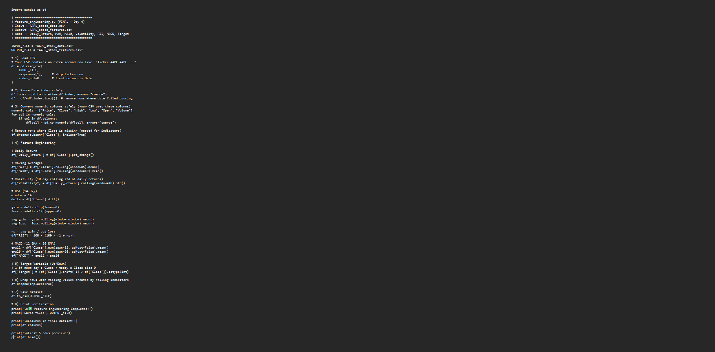
- Screenshot of CMD output confirming successful feature generation (columns list / first 5 rows preview showing RSI and MACD)
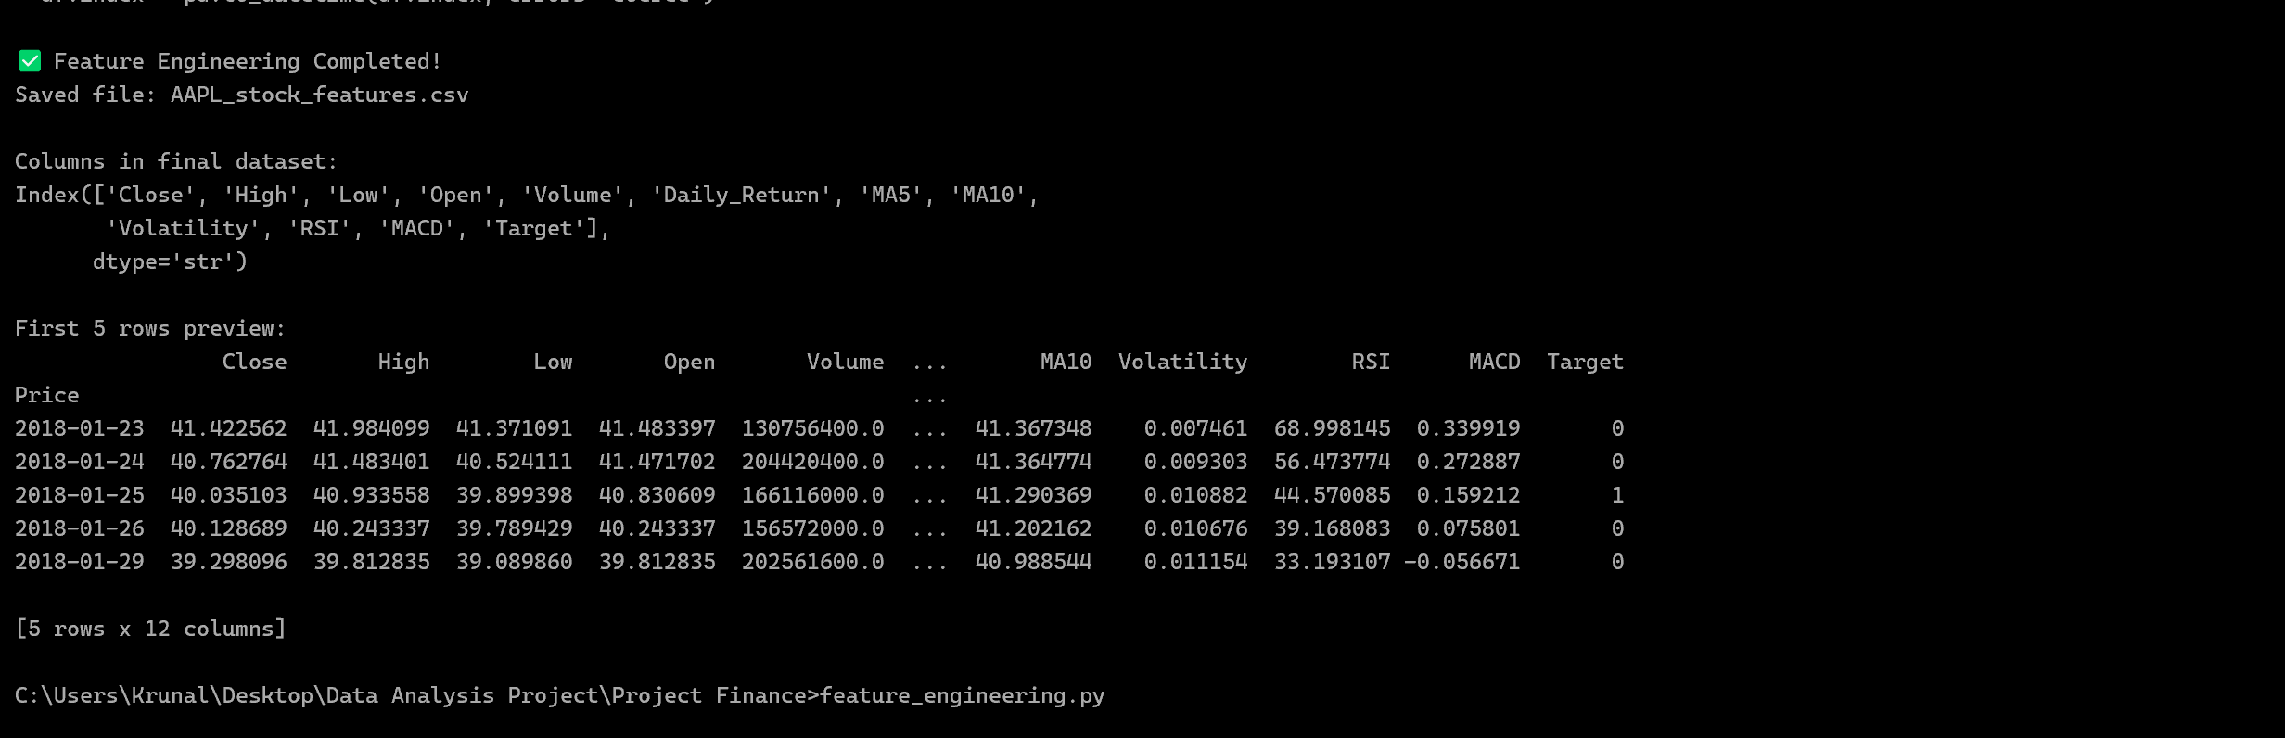
- Screenshot of CMD output showing updated Logistic Regression results
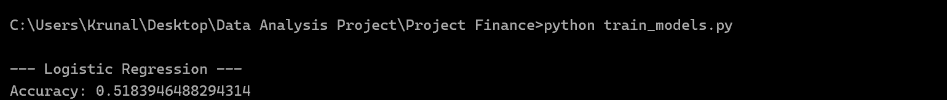
- Screenshot of CMD output showing updated Random Forest results
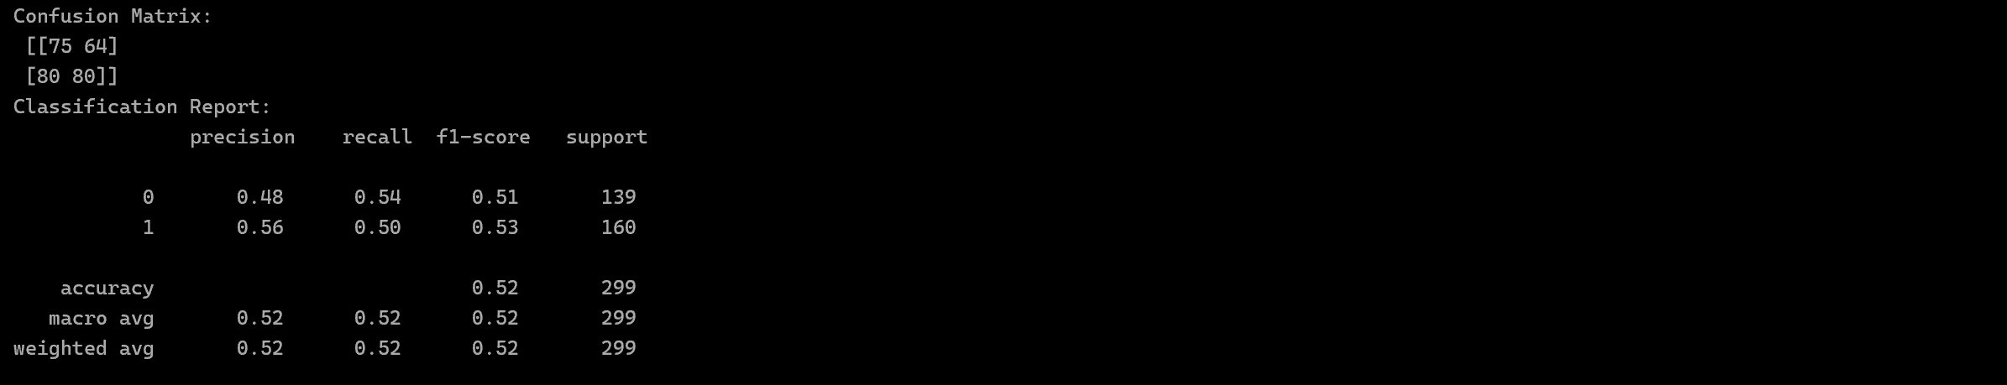
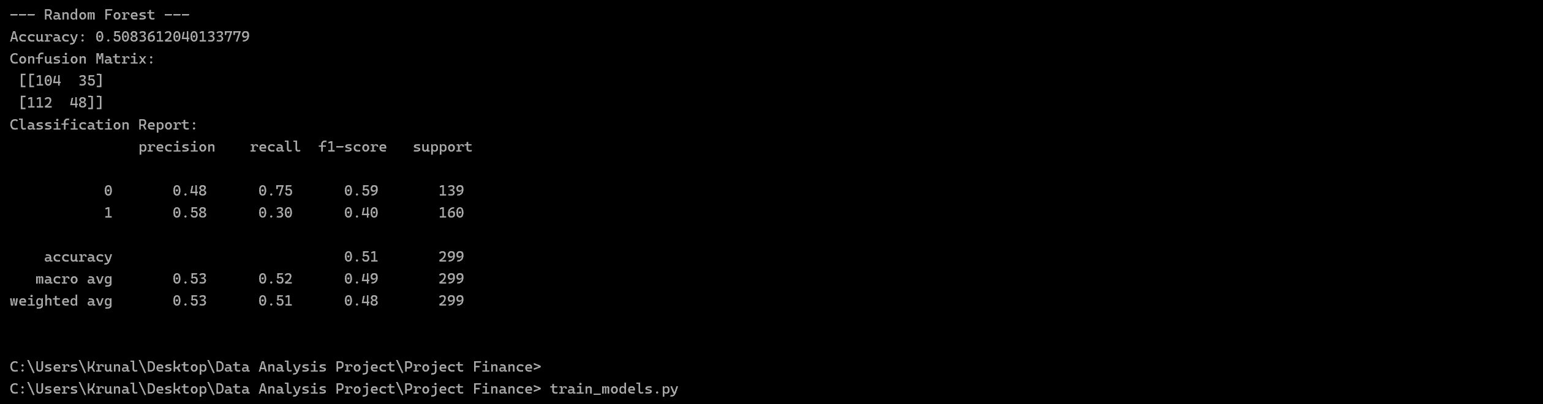
- Screenshot of Random Forest Feature Importance chart after adding RSI and MACD

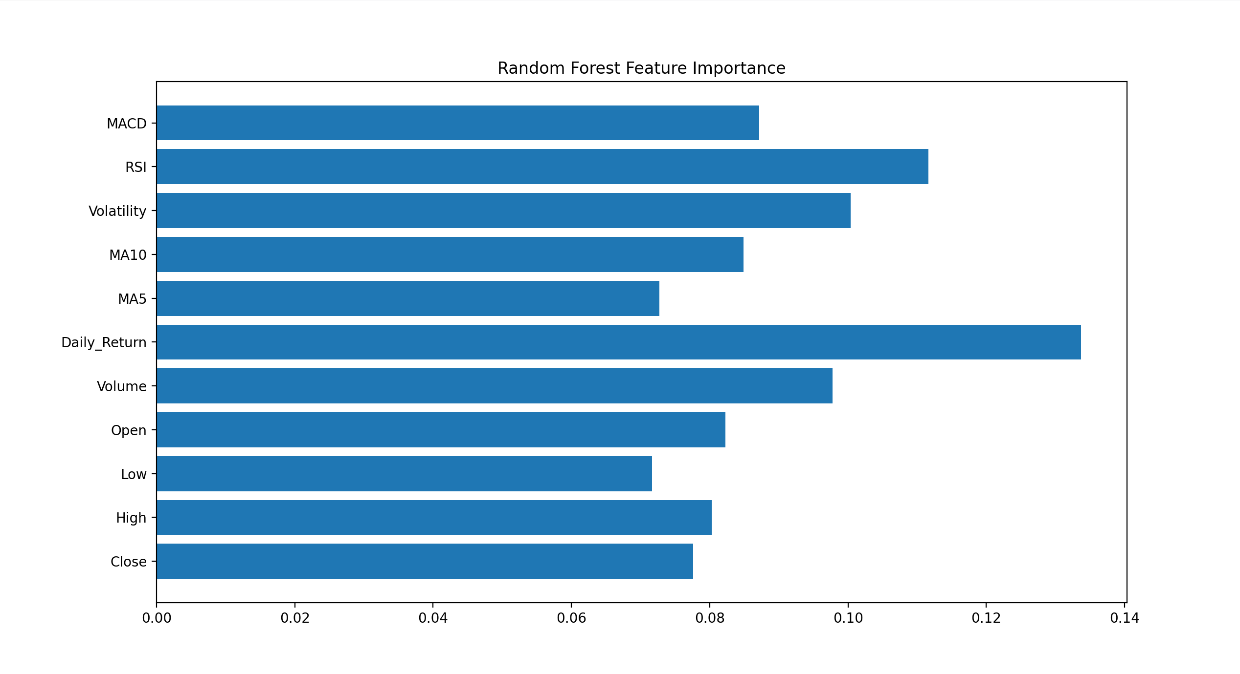

5. Final Evaluation & Model Output

5.1 Project Overview
Focused on finalizing the machine learning workflow by generating prediction outputs, validating model behavior, and preparing the project for documentation and portfolio presentation.
This step ensures that the model produces real prediction results rather than only performance metrics.

5.2 Objective
• Save model predictions into a CSV file
• Compare actual vs predicted values
• Ensure model is not overfitting
• Provide final evaluation summary
• Prepare project for reporting and presentation

5.3 Saving Model Predictions
After training the Logistic Regression and Random Forest models, predictions were generated using the test dataset (unseen data).
The following columns were saved into a new file:
Column | Description
Actual | Real market movement (0 = Down, 1 = Up)
Predicted_Logistic | Prediction from Logistic Regression model
Predicted_RF | Prediction from Random Forest model
The predictions were saved using:
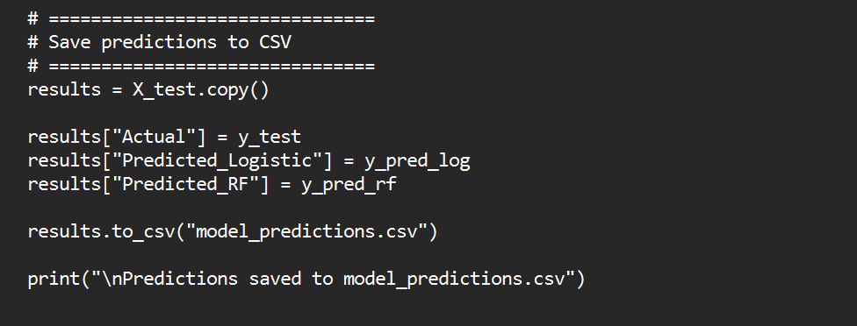
A new file named model_predictions.csv was successfully generated.

5.4 Why the Prediction File Contains Fewer Rows
The original dataset contained several years of historical stock data.
However, the prediction file contains only approximately 20% of the total rows.
This is because the dataset was split using an 80/20 train–test split:
• 80% → Used to train the model
• 20% → Used to test the model
Predictions were saved only for the test dataset to ensure unbiased performance evaluation.
This approach prevents overfitting and reflects real-world predictive capability.

5.5 Final Model Performance Summary
Model | Accuracy
Logistic Regression | ~51.8%
Random Forest (Tuned) | ~50.5%
Both models performed close to the random baseline (50%).

5.6 Interpretation of Final Results
The results indicate that next-day stock direction prediction using basic technical indicators (Daily Return, Moving Averages, Volatility, RSI, MACD) remains highly challenging.
Possible reasons include:
• Market noise
• Short-term price randomness
• Efficient market hypothesis
• Limited predictive power of traditional technical indicators alone
Even after adding RSI, MACD, and tuning the Random Forest model, performance improvements were minimal.

5.7 Project Completion Summary
By the end of project, the following tasks were successfully completed:
✔ Data collection from Yahoo Finance
✔ Feature engineering with technical indicators
✔ Model training (Logistic Regression & Random Forest)
✔ Model evaluation using accuracy and confusion matrix
✔ Feature importance analysis
✔ Hyperparameter tuning
✔ Prediction generation and CSV output
The project now represents a complete end-to-end machine learning pipeline for stock direction prediction.

5.8 Limitations of the Study

• Only technical indicators were used
• No macroeconomic or fundamental data included
• No deep learning models tested
• Short-term (daily) prediction horizon

5.9 Future Improvements
• Incorporate additional indicators (ATR, Bollinger Bands)
• Use advanced models (XGBoost, LSTM)
• Perform cross-validation
• Apply rolling-window backtesting
• Include sentiment or macroeconomic data

5.10 Conclusion
This project demonstrates the complete implementation of a machine learning workflow for financial time-series prediction.
Although the prediction accuracy remained near the random baseline, the project successfully illustrates:
• Data preprocessing
• Feature engineering
• Model development
• Performance evaluation
• Real-world prediction generation
The findings reinforce the complexity and unpredictability of short-term stock market behavior.

Screenshots to Include:
- Screenshot of model_predictions.csv in Excel
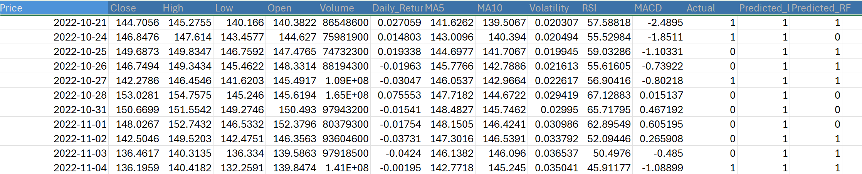
- Screenshot of command prompt showing predictions saved
Screenshot of final model accuracy results

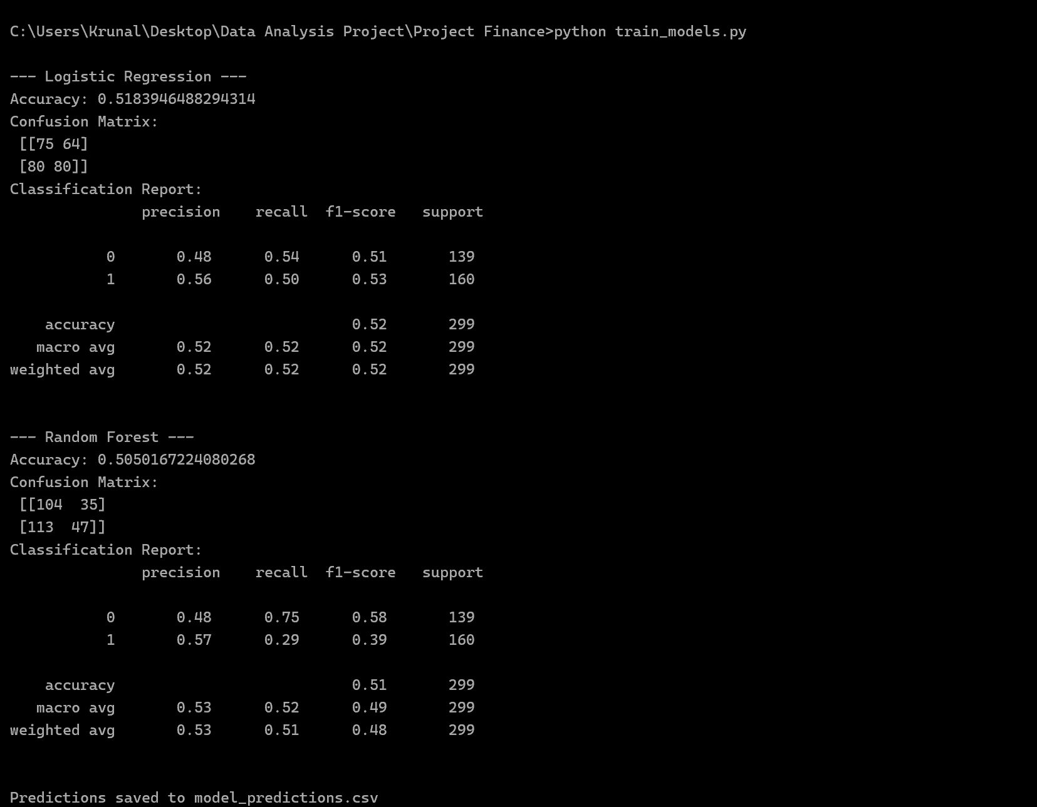

6. Practical Implications

Although predictive accuracy is near random baseline, the project demonstrates how machine learning can be structured for financial data analysis. In real trading systems, such models would be combined with risk management, transaction cost modeling, and portfolio optimization rather than used alone for directional prediction.

